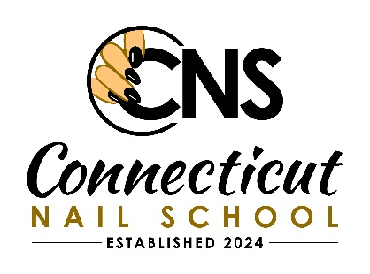
CONNECTICUT NAIL SCHOOL

Nail Technology Program

CLASS START DATE
Every First Week of January 9:30am-9:30pm, 40 hours per week
*Please call to schedule your hours*

- The total curriculum shall not be less than 100 hours of instruction.
- The first 50 hours must be devoted to instruction in the theoretical aspects of all content areas. Practical instruction can be included in this first 50 hours but supervised practice on a clinic floor cannot.
- The remaining 50 hours are to be devoted to supervised practice integrated with ongoing theoretical and practical instruction.

MINIMUM REQUIRED HOURS OF INSTRUCTION
Content Area | Hours
Anatomy and Physiology | 5
Diseases and Disorders of the Skin + Nails | 5
Cosmetic chemistry Ingredients and Product Knowledge | 5
Sterilization, Sanitation and Bacteriology | 5
Management, Laws, Communication and Ethics | 5
Massage, Paraffin Wax application | 5
Application of Manicure, Pedicures and Sales Product Knowledge | 5
Electricity and Nail Technology Equipment | 5
Application of Artificial Nail Enhancements | 10
Clinical Practice, Record Keeping, and Treatment
Procedures & Clinic Hours | 50 | Total 100 Hours

NAIL TECHNOLOGY - ACADEMIC PROGRAM
Week I: Orientation, History + Opportunities, Professional Image, Life Skill, Communication Week II: Infection Control. Anatomy + Physiology
Week III: Skin structure, Nail Structure + Growth, Nail Diseases + Disorders Week IV: Manicuring, Pedi curing Salon Business, Business Planning, Clinic Week V: Basics of Chemistry, Nail Product Chemistry, Tips-Wraps-No Lite Gel Week VI: Acrylic Nail Enhancements, Seeking Employment, Resume
Week VII: UV Gels, Creative Touch, Clinic,
Week VIII: Basics of Electricity, Electric Filing, On the Job, Portfolio Development, Final Exams

Our Nail Class are held morning and afternoon on Monday- Friday 9:30am - 6:30pm.
Cost is $4,000.00 Total – Application, Registration and Supplies fee included
Ask for payment Plan, No Interest.8-week program + introduction, 100 hours
A 75% average in attendance and academics must be maintained for a Certificate / Diploma.

Please come in for a tour so we can get you started on your new career.
Limited Seating Available, a Deposit of $600.00 before the start of Class to ensure Textbooks and Nail kit.

Upon completion you may Apply for State of CT Licensure with the Dept of Health for fee of $100.00.
SCHOOL OPEN HOUR 9:30AM-9:30PM
MORNING CLASS 9:30 - 1:30 - AFTERNOON CLASS 2:00PM-6PM

Evening Class 7:30pm – 9:30pm Start JULY 2, 2024
sign up now online https://ctnailschool.com/
OR
PH: 203-747-2512 EMAIL: CTNAILSSCHOOL@GMAIL.COM
CONNECTICUT NAIL SCHOOL 920 S. COLONY RD., WALLINGFORD, CT 06492

